Cog ex Machina 4.1

Massively scalable computation made easy

Programming

Tutorial

13 May 2016





Table of Content

1. Introduction 4

1.1 Language 4

1.2 Libraries 4

1.3 Versioning 5

2. Abstractions 6

2.1 Tensor Fields 6

2.2 Operators 7

2.3 Compute Graphs 8

3. Introductory Examples 9

3.1 Hello, World 9

3.2 Operators 11

3.3 Sensors 13

3.4 Actuators 14

4. Operators 15

4.1 Arithmetic: + - * / 15

4.2 Convolution 16

4.3 Real unary operators 17

4.4 Real binary operators 17

4.5 Complex operators 18

4.6 Stacking and Slicing 19

4.7 Trimming and Expanding 21

4.8 Shifting and Warping 22

4.9 Subfield and apply(Range) 23

4.10 Tensor Reductions 24

4.11 Field Reductions 25

4.12 WinnerTakeAll 25

4.13 Inner products 26

4.14 ProjectFrame, BackProjectFrame and ConvolveFilterAdjoint 26

4.15 User-defined operators 26

4.16 GPUOperators 27

4.17 Further operator documentation 28

5. Programming Cog Applications 29

5.1 Feed-forward computation 29

5.2 Feedback for adaptation 31

5.3 Reset and step 32

5.4 Programming styles in Cog: Think functional 33

6. Debugging 34

6.1 Launching the Debugger 34

6.2 Probing Fields 35

6.3 Controlling the Computation 35

6.4 Viewing Compute Graph Structure 36

6.5 Visualizing Field Contents 39

6.6 Standard Field Visualizations 39

6.6.1 Scalar Fields 40

6.6.2 Vector Fields 40

6.6.3 Matrix Fields 40

Appendix A: Field Operator and Function API 41

# 1. Introduction

Cog ex Machina, or “Cog” for short, is a software platform for developing autonomous, adaptive, massively-parallel applications that execute on digital, multi-core processors, such as GPUs, distributed across a local network. Its design is motivated by the need to process vast amounts of “rich” media in real time. It is designed to scale to millions of cores.

Cog differs from most other parallel programming paradigms (such as MPI, actors, transactional memory) by exposing the parallelism implicitly in the programming model rather than through explicit mechanisms and data structures. The model contains no threads, locks, message queues, critical sections, or races. It is a *deterministic*, *massively-parallel* programming model. It is also a *declarative* *dataflow* programming model, meaning that a Cog application describes the structure of the computation, not sequential actions. Since learning and adaptation (as opposed to hardwired feed-forward behavior) are prime objectives of Cog, this is both unavoidable and desirable.

This manual is an informal tutorial about programming on Cog using a series of simple examples, most of which can be obtained from the Cog project’s *tutorial* Git repository. This manual also discusses the Cog programming API at a high level, but then also includes the Scaladoc of the complete API as an appendix. The companion document, Cog System Setup Guide, explains how to install Cog on a single machine or cluster.

## 1.1 Language

Cog is written in the Scala programming language which runs on the Java Virtual Machine (JVM).

## 1.2 Libraries

Cog is distributed as a set of Scala libraries, and is organized in three components: the core library, a graphical debugger, and an I/O library.

The core Cog library may be accessed with a single import statement:

import libcog._

libcog implements the Cog API and contains the compiler and runtime system necessary to optimize and distribute a Cog application.

The debugger is accessed by importing:

import cogdebugger._

cogdebugger provides a graphical debugger that is used for single-stepping and probing the internals of a Cog application as it runs.

The I/O library is accessed by importing:

import cogio._

cogio provides a set of objects useful for getting data into and out of a running Cog app using the field initialization, sensor, and actuator primitives that are part of the core Cog API.

## 1.3 Versioning

This document refers to Cog version 4.1.

# 2. Abstractions

The Cog programming model has three core abstractions: tensor fields, operators, and compute graphs. A tensor field is a multi-dimensional array (field) of multidimensional arrays (tensors) of elements (e.g. 32-bit floating point numbers). Fields are used to represent inputs, outputs, computational intermediates, and persistent state. An operator combines one or more tensor fields to create a new tensor field; it performs the computation in an application and controls data flow. A compute graph combines tensor fields and operators into a single, massively-parallel unit of computation that may be embedded in, and controlled by, a conventional application. Compute graphs are state machines which evolve in discrete *time*, where a single tick of the Cog clock is abstracted as the period during which data flows completely from the inputs of a compute graph to its outputs. Persistent state (and hence learning, adaptation, and iteration) is handled by using *feedback*; that is, the state of a field at a given time can be fed back onto itself or another field at the next Cog tick in order to provide control loops and learning. Restricting the programming model to these simple abstractions provides sufficient information for the Cog compiler to optimize computation across operators and distribute computation efficiently on systems that scale from one CPU to clusters of millionsof GPU cores.

## 2.1 Tensor Fields

The word tensor has different connotations in math, physics and engineering, but we will use the simplest definition that appears to be popular in machine learning: a multi-dimensional array of numbers. Numbers may be real or complex; we will use the word element to refer to a number in a tensor regardless of type. The number of dimensions of a tensor’s array of numbers is called the tensor’s order. An order-0 tensor is called a scalar and contains a single number. An order-1 tensor is called a vector and contains one or more numbers. An order-2 tensor is called a matrix. Higher order tensors don’t have generally agreed-upon names, so Cog calls these Tensor3, Tensor4, etc…, where the numeric suffix specifies the order. Currently Tensor3 is the highest order tensor supported in Cog, though this can easily be extended. Here are some graphical examples, where each red dot denotes a number / element:

*Tensors*

Order 0

Scalar

Order 1

Vector

Order 2

Matrix

Order 3

Tensor3

Order 3

Tensor3

*tensor element (number)*

A tensor field is a multidimensional array of tensors, with all tensors in the field having exactly the same order and shape. A field may have zero, one, two or three dimensions. A zero-dimensional field holds a single tensor.

dimensions: 3

field shape: (3, 3, 2)

tensor shape: (2, 2)

tensor order: 2 (matrix)

tensor

Tensor Field

*tensor element*

*(number)*

The following field types are supported by the Cog core, and additional field types may be defined by the user:

ScalarField

VectorField

MatrixField

ComplexField (a scalar field with complex elements)

ComplexVectorField (a vector field with complex elements)

ColorField (a field where each order-1 tensor is a pixel)

Each tensor of a ScalarField has a single real tensor element, whereas each tensor of a ComplexField has a single complex tensor element. VectorFields and MatrixFields generally have multiple tensor elements per tensor. The tensor elements of the real fields (the ScalarFields, VectorFields and MatrixFields) are 32-bit floating point values (“floats”), while the tensor elements of the complex fields (ComplexField and ComplexVectorField) are complex numbers whose real and imaginary components are also floats. A ColorField is actually a vector field holding three low-precision (8-bit) integer values. A ColorField vector, also called a pixel, holds three, 8-bit color channels (red, green, blue).

## 2.2 Operators

An operator takes one or more tensor fields and computes a new tensor field as a result. For example, the + operator can be used to combine two real or complex tensor fields with the same shape and tensor order into a new field with the same shape and order, where each tensor element is the sum of the corresponding tensor elements in the operands:

tensor field

operator

tensor field

tensor field

Operator:

Cog supports the usual arithmetic operators on real and complex fields which operate on the corresponding tensor elements of the two input fields:

+ - * /

Beyond these basic operators, Cog supplies a rich set of algebraic and transcendental operators, in addition to a number of operators useful to signal processing and cognitive models. The full set of operators is described in Chapter 4 and the operator API is presented in Appendix A.

One important operator introduced by the Cog programming framework is the feedback operator

<==

which is used to evolve state within a computation. This is essential for learning and adaptation.

## 2.3 Compute Graphs

Tensors fields and operators are combined to create a computation unit called a *compute graph*:

*Compute Graph*

tensor field

operator

tensor field

tensor field

actuator

sensor

(feedback)

<== operator

The compute graph brings in information from the outside world into the computation with *sensors*, which are tensor fields that are sourced by external data streams such as video cameras, microphones, touch sensors, databases, or files. The compute graph sends out information or enacts side-effects through *actuators*, which are tensor fields that source external data streams such as consoles, video displays, speakers, databases, or files.

A single step of computation in the graph proceeds in two phases. In the first phase, operators propagate field information bottom-up from sensors to actuators, ignoring any feedback connections (shown as a dashed line in the above figure). In the second phase, the feedback information is used to change the state of each field receiving a feedback connection, specified by the <== operator. This is essentially a state machine: each step of computation reads input data (sensors) to produce new outputs (actuators) and updates its internal state.

A user may create a compute graph and “step” its computation by repeatedly calling a step method, and may reset its state to user-specified initial value by calling a reset method.

# 3. Introductory Examples

A ComputeGraph can be embedded within an application, but it is easier to learn the programming model and develop apps by using the Cog debugger, a graphical tool that allows you to step, reset, and “peek inside” a ComputeGraph to visualize the computation while it executes. We will primarily use the debugger along with some visual examples for the purposes of exhibition in this guide, but keep in mind that the debugger generally will not be used for app deployment and the Cog model can be used for processing and interacting with arbitrary types of data.

## 3.1 Hello, World

Let’s start with a simple ComputeGraph that runs in the debugger:

**package** tutorial.libcog.fields

**import** libcog._

**import** cogdebugger._

**object** Counter **extends** CogDebuggerApp(

**new** ComputeGraph {

**val** *counter* = *ScalarField*(200, 200)

*counter* <== *counter* + 1

}

)

The Cog debugger wraps the compute graph, emulating the embedding of the graph in an application. Note that applications may create and control multiple ComputeGraphs if desired, but ComputeGraphs may not be nested. In the above code, the “import libcog._” statement provides your program access to all Cog functionality. The “import cogdebugger._” gives access to the Cog debugger.

This application contains a two-dimensional scalar field named “counter.” If you compile and run the above application, you will see a window that looks like this:

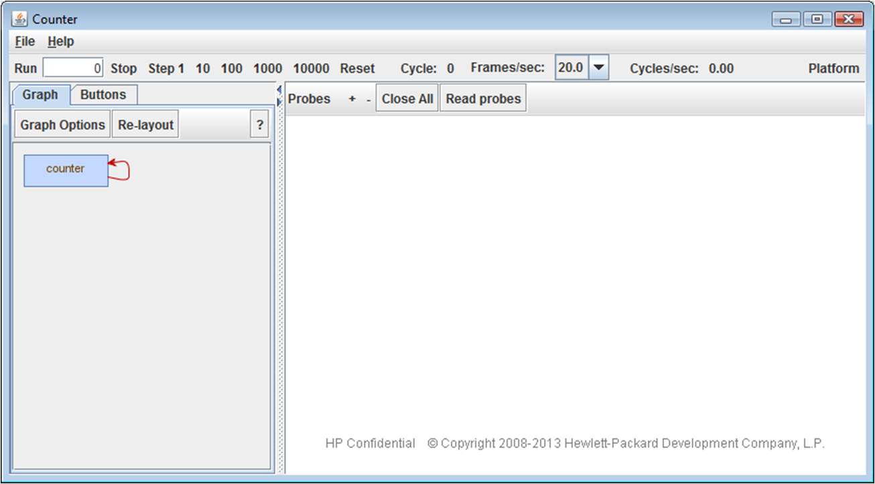

The blue box in the upper left labeled “counter” is the graphical representation of the field named “counter” in the code. The box label text “counter” is taken from the variable name of the field in the code. Clicking on the blue box will cause a window to open which displays the current state of that field as a grayscale image:

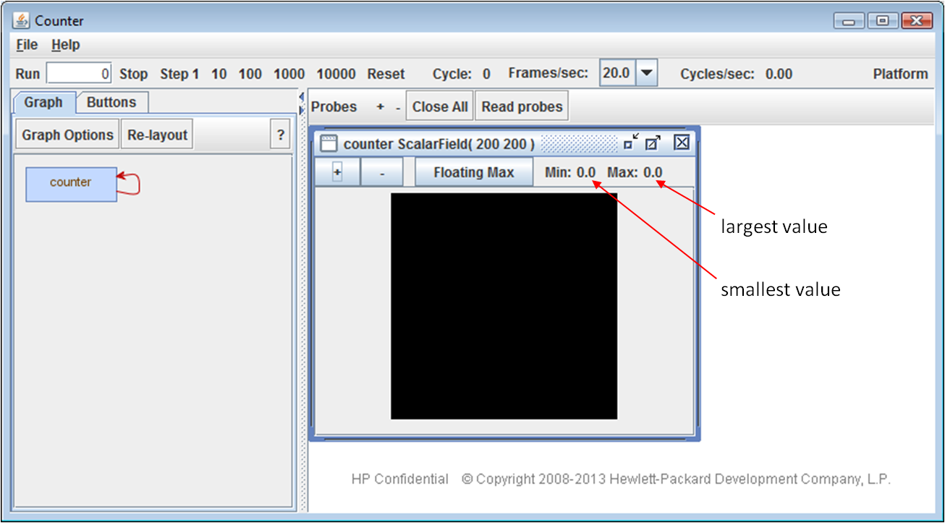

The black box above is a 200 x 200 image, with each pixel displaying the corresponding value of a real scalar within the dynamic field. The color coding of values is shown, with the smallest value represented by black and the largest by white. Since fields are initialized by default to all zeros, this displays each scalar as a black pixel.

Clicking on the “step 1” button in the debugger will “clock” the field, causing it to change its state by executing the line of code called the “mutation operation”:

counter <== counter + 1

This statement says that the next state of the field, after the next clock tick, is equal to the current state of the field with 1 added to every point in the field. Since there are 40,000 points in the field, this statement is describing 40,000 additions. Here’s what you’ll see in the debugger after stepping once:

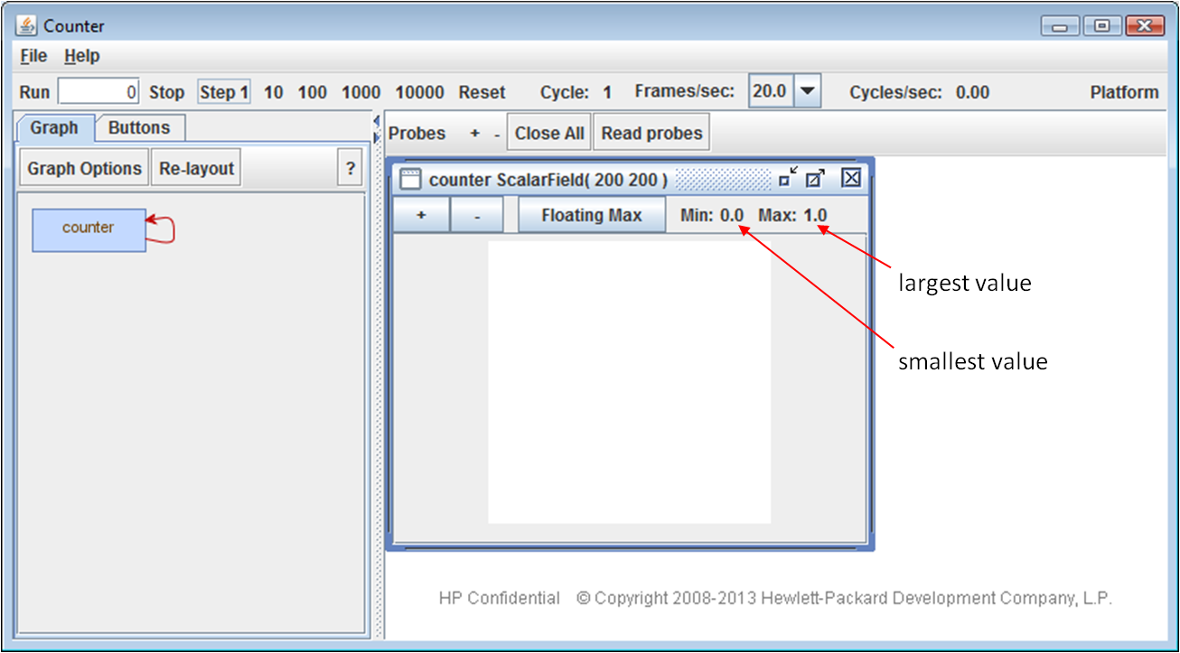

Since every point in the field is now equal to one, the image representing that field uses 40,000 white pixels to represent the field state. Clicking “step 1” again will increment the points in the field so that they each have the value 2. Placing the cursor over a point in a field will momentarily bring up a tooltip describing the coordinates and precise value at that point.

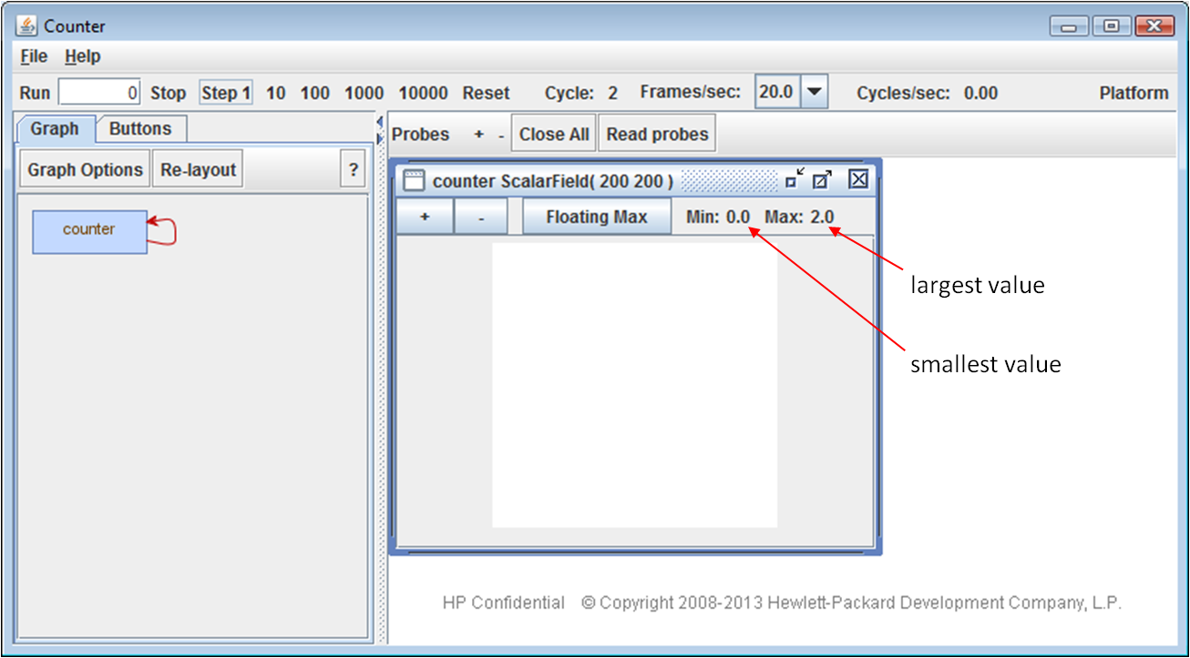

## 3.2 Operators

Here’s a simple example of combining two fields to create a new one:

**package** tutorial.libcog.fields

**import** libcog._

**import** cogdebugger._

**import** cogio._

**object** MultipleFields **extends** CogDebuggerApp (

**new** ComputeGraph {

**val** *grass* = *GrayscaleImage*(**"resources/grass.jpg"**)

**val** *leaves* = *GrayscaleImage*(**"resources/leaves.jpg"**)

**val** *average* = (*grass* + *leaves*)/2

probeAll *// Makes all fields visible in the debugger*

}

)

This example utilizes the IO Library which includes a number of useful functions for getting data into a compute graph. In this example we use the cogio object GrayscaleImage, a function object that initializes a scalar field with data from an image file. In this example, two fields named “grass” and “leaves”, which are necessarily the same size, are averaged to create the field “average.” Here’s what you should see:

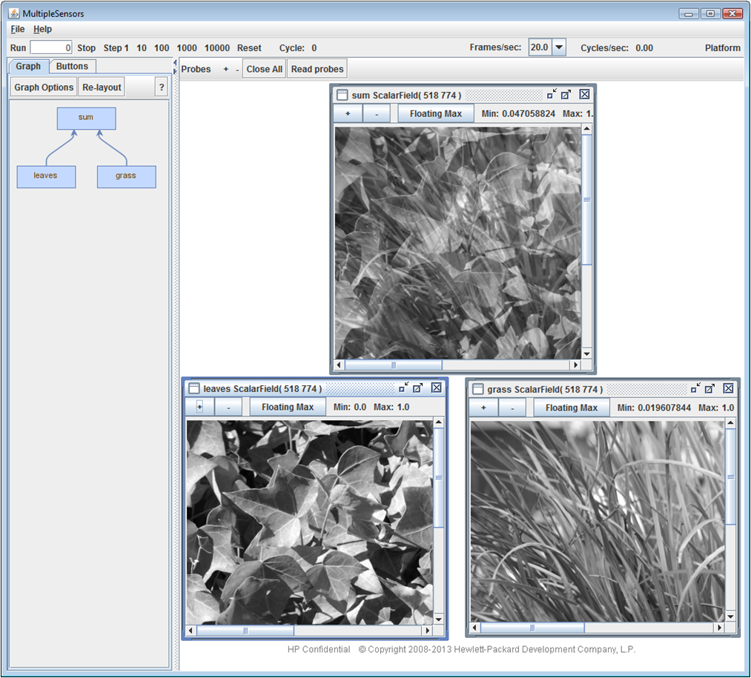

## 3.3 Sensors

Sensors pull in streams of data as a stream of fields, one for each Cog tick. Here’s an example of reading in a movie file in a sensor:

**package** tutorial.cogio

**import** libcog._

**import** cogdebugger._

**import** cogio._

**object** ColorMovieExample **extends** CogDebuggerApp (

**new** ComputeGraph {

**val** *movieFile* = **"resources/Wildlife.wmv"**

**val** *movie* = *ColorMovie*(*movieFile*)

}

)

Here we use the IO library function ColorMovie to create field from a movie file. Since the movie will evolve over time, ColorMovie creates a Cog Sensor which provides an interface for data flow from the outside world into the compute graph at each Cog tick. Executing this example, then clicking on the movie box followed by clicking Run will play the movie within the debugger, displaying one frame per Cog tick.

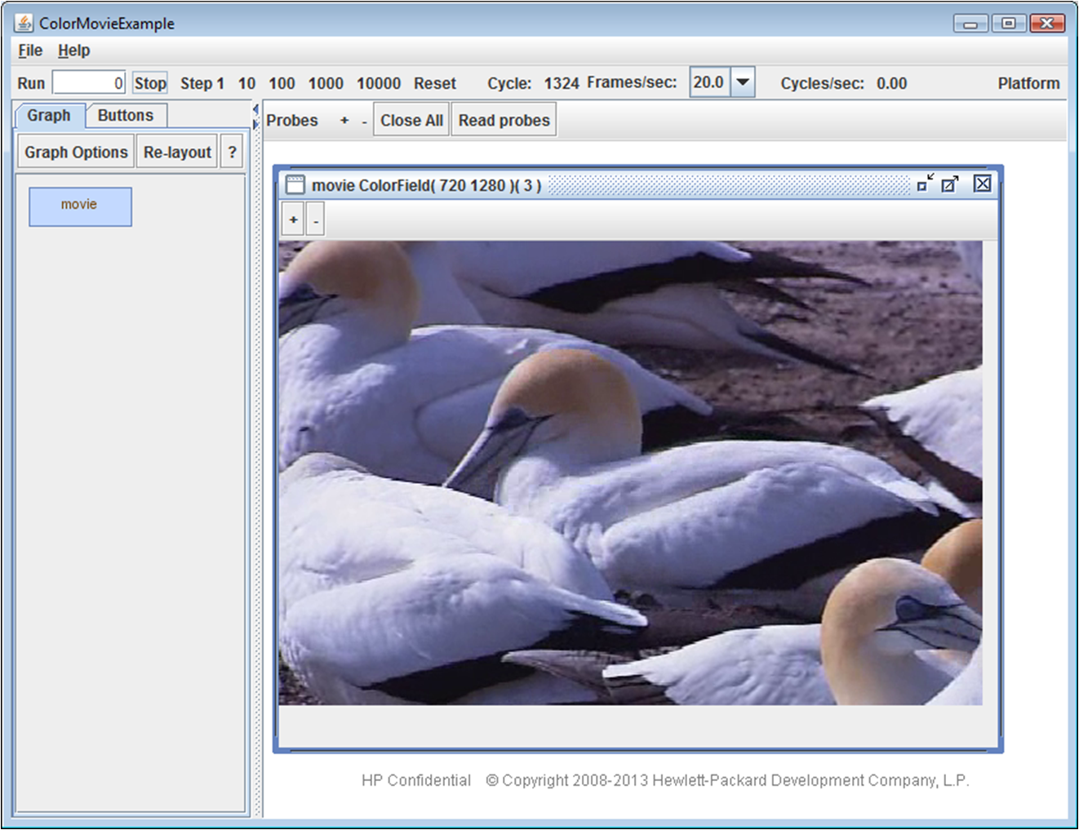

## 3.4 Actuators

Actuators complement sensors; they are a mechanism for exporting data or executing data-dependent side effects from within compute graphs. Here’s a simple application which creates a one-dimensional scalar field with simple feedback and prints it out each time the computation is stepped:

**package** tutorial.libcog.actuators

**import** libcog._

**object** ActuatorExample **extends** App {

**val** graph = **new** ComputeGraph {

*// Initialize a field to (1,2,3,4)*

**val** field = ScalarField(4, (column) => 1 + column)

*//Increment each element by one each tick*

field <== field + 1

*// define an actuator that outputs the field elements to an array each tick*

*// and specifies an initial actuator state of (4,3,2,1)*

**val** actuatorData = **new** Array[Float](4)

**val** actuator = Actuator(field, actuatorData, (column) => 4 - column)

}

**import** graph._

withRelease {

*// reset the graph, print actuator data*

reset

println(actuatorData.mkString(**" "**))

*// step the graph 5 times, print actuator data after each step*

**for**(i <- 0 until 5) {

step

println(actuatorData.mkString(**" "**))

}

}

}

Note that since no special I/O is used we do not import cogio and since we are just printing to the console we do not import cogdebugger. Since we are not using the debugger here, we programmatically step the graph each time we want to write output to the console. By importing graph._, we can refer to various methods and fields of the compute graph simply. The withRelease method ensures the release of the compute graph at the end of the computation, which allows the runtime system to release the CPU and GPU memory it has claimed and shut down gracefully. When executed, this will print the following to the console:

4.0 3.0 2.0 1.0

1.0 2.0 3.0 4.0

2.0 3.0 4.0 5.0

3.0 4.0 5.0 6.0

4.0 5.0 6.0 7.0

5.0 6.0 7.0 8.0 5.0 6.0 7.0 8.0 5.0, 6.0, 7.0, 8.0

Please consult section 5.1 “Feed-forward computation” for more insight into Sensor and Actuator operation.

# 4. Operators

All field operations in Cog are expressed using operators, described in this chapter.

## 4.1 Arithmetic: + - * /

Two dynamic fields may be combined arithmetically if: (1) both fields have the same field shape, or at least one of the field shapes is zero-dimensional; and (2) both fields have the same tensor shape, or at least one of the tensor shapes is zero-dimensional (i.e. the field is a ScalarField or ComplexField). The output field shape and tensor shape are determined as described by the following pseudo-code:

outFieldShape = if (is0D(in1FieldShape)) in2FieldShape else in1FieldShape

outTensorShape = if (is0D(in1TensorShape)) in2TensorShape else in1TensorShape

One caveat is that the output must have the same field shape and tensor shape as one of the inputs. Thus, the combination of a zero-dimensional vector field and a multi-dimensional scalar field is not allowed as the multi-dimensional vector field output is unlike either input. The input that is unlike the output can appear as either the first or second operand. If either input is a complex field, then the output will be also.

Some examples:

**val** fieldShape = Shape(100,100)

**val** bigFieldShape = Shape(200, 200)

**val** vectorShape = Shape(5)

**val** scalarField = ScalarField(fieldShape)

**val** bigScalarField = ScalarField(bigFieldShape)

**val** vectorField = VectorField(fieldShape, vectorShape)

**val** matrixField = MatrixField(fieldShape, Shape(7, 7))

**val** complexField = ComplexField(fieldShape)

**val** complexVectorField = ComplexVectorField(fieldShape, vectorShape)

**val** zeroDimScalarField = ScalarField(1.234f)

**val** zeroDimVectorField = VectorField(**new** Vector(5))

**val** x1 = scalarField + scalarField *// OK*

**val** x1c = complexField + complexField *// OK*

**val** x2 = scalarField – bigScalarField *// ILLEGAL, different field shapes*

**val** x3 = vectorField * scalarField *// OK*

**val** x3c = complexVectorField * scalarField *// OK*

**val** x4 = vectorField / complexField *// OK*

**val** x4c = complexVectorField / complexField *// OK*

**val** x5v = vectorField * vectorField *// OK (element-wise multiplication)*

**val** x5m = matrixField * matrixField *// OK (element-wise multiplication)*

**val** x5c = complexMatrixField * matrixField *// OK (element-wise multiplication)*

**val** x5c = complexVectorField * complexVectorField *// OK (element-wise multiplication)*

**val** x5c2 = complexVectorField * vectorField *// OK (complex <op> real)*

**val** x6 = vectorField + zeroDimVectorField *// OK, vector field <op> 0D vector field.*

**val** x7 = vectorField + zeroDimScalarField *// OK, vector field <op> 0D scalar field.*

**val** x8 = scalarField + zeroDimScalarField *// OK, scalar field <op> 0D scalar field.*

**val** x9 = vectorField * matrixField *// ILLEGAL, incompatible tensor shapes*

**val** x10 = scalarField + zeroDimVectorField *// ILLEGAL, scalar field <op> 0D vector field*

Color fields are arithmetically incompatible with all other field types since their element type (color pixel) is non-numeric. If you want to perform operators on color fields you must first explicitly cast them as vector fields by using colorField.toVectorField.

## 4.2 Convolution

Two-dimensional ScalarFields, ComplexFields, and VectorFields can be convolved with a filter (expressed as a real or complex field). Here’s an example of applying a Laplacian filter to differentiate an input:

**package** tutorial.libcog.fields

**import** libcog._

**import** cogdebugger._

**import** cogio._

**object** Convolution **extends** CogDebuggerApp(

**new** ComputeGraph {

**val** *leaves* = *GrayscaleImage*(**"resources/leaves.jpg"**)

*//manually define the elments in the filter*

**val** *filterElements* = *Array*(

*Array*(0f, 1f, 0f),

*Array*(1f, -4f, 1f),

*Array*(0f, 1f, 0f)

)

*//create a static filter field based on the filter elements*

**val** *filter* = *ScalarField*(3,3, (r,c)=>*filterElements*(r)(c))

*//perform convolution with the BorderClamp border policy*

**val** *filtered* = convolve(*leaves*, *filter*, *BorderClamp*)

probeAll

}

)

This example details how you can initialize fields in Cog: you must supply the shape and type of the field along with a function object which defines how to initialize it. In this case we simply define a 2D array by hand and then access that array in the constructor function. After defining the filter we perform the convolution with the convolve operator. Note that the convolve operator requires a BorderPolicy, which defines how the border is handled during convolution. Here’s what you’ll see when you execute this program:

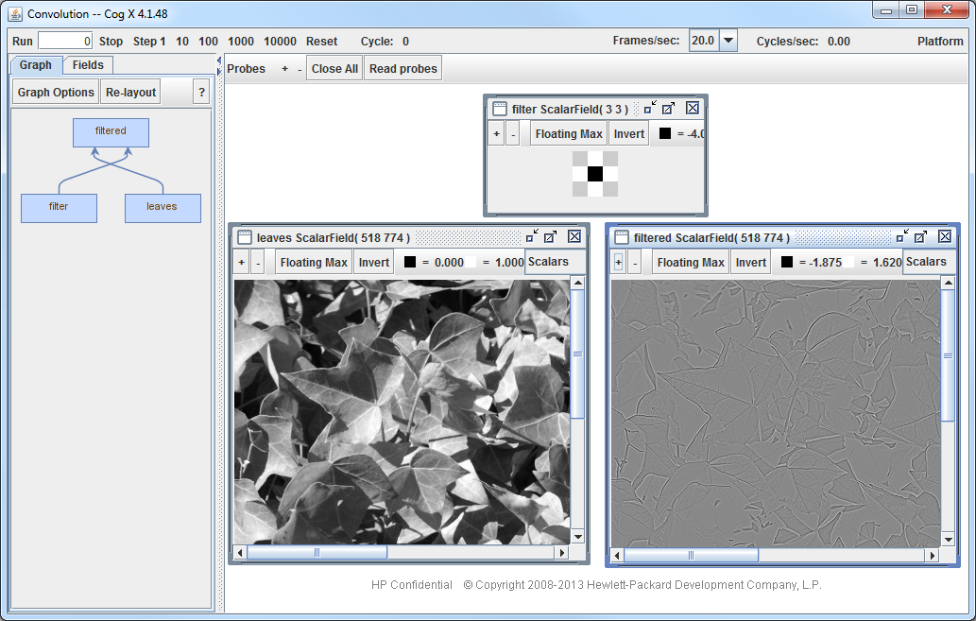

## 4.3 Real unary operators

All real dynamic fields (scalar, vector and matrix) may have the following operators applied to each numeric component of each tensor in the field. The result is a field with the same type and shape as the input.

abs acos acosh asin cos cosh exp floor log signum

sin sinh sq sqrt tan tanh - (unary minus)

The following operators take a real dynamic field and constant scalar as operands and compute a result by applying the operator to each tensor element independently. Since these operations involve only one field operand, they are listed here as unary operators:

+ - * / % > >= < <= === !===

pow max min

The constant operand supplied in the user’s code must be a Float or an Int. While the pow operator accepts both integer and floating point constants, all other operators will effectively convert an Int operand to a Float before the operation proceeds. Double (i.e. 64-bit floating point) constants are not accepted syntactically- use toFloat() or append an ‘f’ as in 0.0f. The operators that test for equality and inequality include three ‘=’ characters to avoid confusion with their Scala counterparts ‘==’ and ‘!=’.

## 4.4 Real binary operators

The following binary operators take two real fields (scalar, vector or matrix) with the same shape and produce a result of the same shape with elements created by applying the binary operator to corresponding elements in the two input fields:

+ - * / % > >= <= === !=== max min atan2

As discussed in section 4.1, these operators also work if one of the operands has a 0D field shape and/or 0D tensor shape. In these cases, the data of these degenerate inputs is conceptually replicated along the missing field shape or tensor shape dimensions.

## 4.5 Complex operators

Complex fields are particularly useful for processing in the frequency domain. Many algorithms involve correlations across a field; those can often be performed much more efficiently by transforming the algorithm between the space and frequency domains using the fast Fourier transform. The standard complex binary arithmetic operators (+, -, *, /) are supported for complex fields as are the following unary operators:

exp conjugate - (unary minus)

While the above complex unary operators produce complex fields, the following additional operators produce real fields:

phase orientation magnitude realPart imaginaryPart

Here’s a screenshot of a complex field application, BoundaryCompletion (in the tutorial.toolkit.filtering package), that solves the problem of “filling-in” broken straight and curved line segments, a necessary step for recognizing partially occluded objects. This application uses a number of tricks, including data compression, steerable theory, and frequency domain convolution, to enable real-time completion of boundaries:

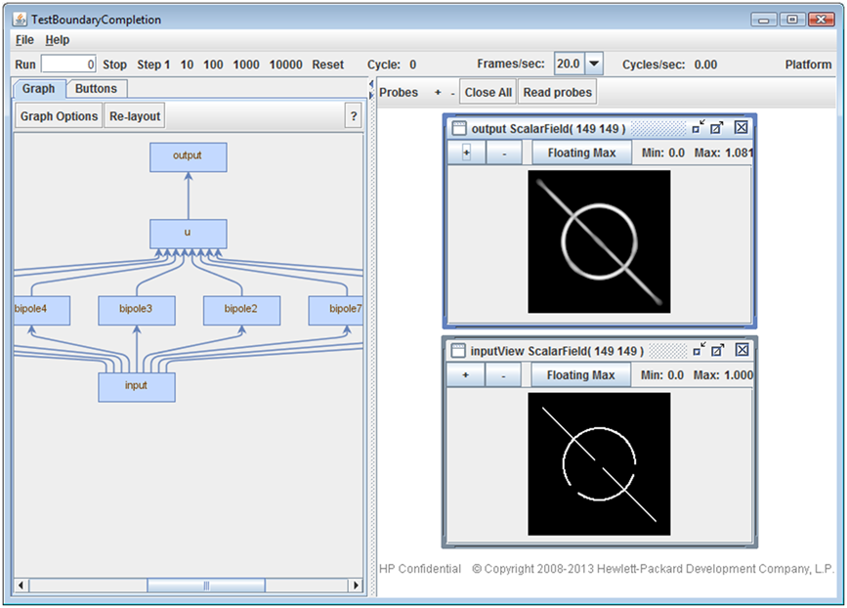

## 4.6 Stacking and Slicing

In addition to the transformations already discussed, such as algebraic combinations or convolution, it’s sometimes necessary to merge or break apart tensor fields. Combining two or more fields is called *stacking*; extracting a portion of a field is called *slicing*.

Stacking takes two or more fields, each with exactly the same field and tensor shapes, and combines them into a higher dimensional tensor field. Here’s an example of combining three 2-dimensional scalar fields into a single 3-dimensional scalar field:

// 2-dimensional scalar fields

val field0 = ScalarField(Rows, Columns)

val field1 = ScalarField(Rows, Columns)

val field2 = ScalarField(Rows, Columns)

// Stacking creates a 3-dimensional field

val stackedField = stack(field0, field1, field2)

Notice that the resulting stacked field has a one-higher dimension than the component fields that comprise it. This new dimension is indexed first.

Stacking also works with higher-order fields, such as vector fields or matrix fields. Here’s an example of stacking vector fields:

// 2-dimensional vector fields

val vectorShape = new Shape(5)

val field0 = VectorField(Rows, Columns, vectorShape)

val field1 = VectorField(Rows, Columns, vectorShape)

val field2 = VectorField(Rows, Columns, vectorShape)

// Stacking creates a 3-dimensional vector field

val stackedField = stack(field0, field1, field2)

The stack operators shown so far increase the dimension of the component fields. It’s also possible to stack fields in a way that preserves the field dimensionality but increases the order of the tensors in the resulting field. For example, you might want to stack three scalar fields into a vector field. The operator for stacking fields at the “tensor level” rather than the “field level” is named after the resulting field type. Here’s an example stacking 3 scalar fields into a vector field:

// 2-dimensional scalar fields

val field0 = ScalarField(Rows, Columns)

val field1 = ScalarField(Rows, Columns)

val field2 = ScalarField(Rows, Columns)

// Create a 2-dimensional vector field, with each vector in the

// field of length 3

val stackedField = vectorField(field0, field1, field2)

These “tensor stacking” operators also require that all input fields have exactly the same field and lattice tensor, just like the stack operator.

In a very similar manner, you can also stack vector fields into a matrix field. The number of rows in each matrix is equal to the number of scalar fields that are being stacked; the number of columns is equal to the length of the vectors in the input vector fields. Here’s an example of stacking vector fields to a matrix field:

// 2-dimensional vector fields

val vectorShape = new Shape(5)

val field0 = VectorField(Rows, Columns, vectorShape)

val field1 = VectorField(Rows, Columns, vectorShape)

val field2 = VectorField(Rows, Columns, vectorShape)

// Create a 2-dimensional matrix field. Each matrix has 3 rows, 5 columns

val stackedField = matrixField(field0, field1, field2)

The inverse of stacking is “slicing,” and there are both field and tensor variants of it as well. Field slicing takes an N dimensional field and extracts an N-1 dimensional field indexed along the first dimension. The field slicing operator is the Scala “apply” operator. Here’s an example of slicing a 2-dimensional scalar field to extract 1-dimensional fields:

// 2-dimensional scalar field

val field = ScalarField(Rows, Columns)

// Extract row 0 of field by slicing.

val row0 = field(0)

// Extract row 1 of field by slicing.

val row1 = field(1)

You may slice higher-order fields (vector fields, matrix fields) as well.

Slicing at the “tensor level” rather than the “field level” may be done using the lattice slicing operators, vectorElement(index) or matrixRow(index). These operators return a field with the same field shape as the input, but the order of the tensors in that returned field is one less than in the input field. For example, a matrix field can be sliced to a vector field:

// 2-dimensional matrix field

val matrixShape = new Shape(5, 7)

val field = MatrixField(Rows, Columns, matrixShape)

// Extract row 0 of each matrix in “field,” creating a vector field.

val row0 = matrixRow(field, 0)

// Extract row 1 of each matrix in “field,” creating a vector field.

val row1 = matrixRow(field, 1)

Similarly a vector field can be sliced to form a scalar field:

// 2-dimensional vector field

val vectorShape = new Shape(3)

val field = VectorField(Rows, Columns, vectorShape)

// Extract element 0 of each vector in “field,” creating a scalar field.

val element0 = vectorElement(field, 0)

// Extract element 1 of each vector in “field,” creating a scalar field.

val element1 = vectorElement(field, 1)

## 4.7 Trimming and Expanding

The trim operator reduces the field size of a field by discarding an unneeded border region. Conversely, the expand operator increases the field size of a field while supplying additional border elements per the specified “borderPolicy” argument.

Here’s a simple example using trim and expand:

// Create a 2-dimensional scalar field with contents:

// 0 1 2

// 3 4 5

// 6 7 8

val field = ScalarField(rows=3, columns=3, (r,c) => r*3+c)

// Trim the field to a smaller field shape with contents:

// 0 1

// 3 4

val trimmed = trim(field, Shape(2,2))

// Expand the trimmed field back to a 3x3 shape, with new elements being 0:

// 0 1 0

// 3 4 0

// 0 0 0

val expanded = expand(trimmed, BorderZero, Shape(3,3))

The supported border policies available with expand are BorderZero, BorderClamp and BorderCyclic. The BorderZero policy supplies 0.0f for the additional border elements as shown in the previous example. With the BorderClamp policy, the border values along all four input edges are copied into the expanded output field, wrapping around as though the output field were a torus. This is useful when doing convolution with the FFT and one wishes to minimize border effects by "border clamping". And finally with the BorderCyclic policy, the supplied border values are taken from a cyclic “wrap-around” view of the input. This policy is useful when expanding a field size to make it a power of 2 in each dimension prior to performing a cyclic convolution using the FFT. Further numeric examples of expand with the various border policies are given in the Scaladoc.

## 4.8 Shifting and Warping

The expand and trim operators just presented alter a field’s shape while preserving the data origin. Conversely, the shift and warp operators move the origin of the data while preserving the field shape.

Here’s a simple example using shift:

// Create a 2-dimensional scalar field with contents:

// 0 1 2

// 3 4 5

// 6 7 8

val field = ScalarField(rows=3, columns=3, (r,c) => r*3+c)

// Shift the field 1 element up and 2 elements to the right:

// 0 0 3

// 0 0 6

// 0 0 0

val shifted = shift(field, -1, 2)

// Shift the field *cyclicly* 1 element down and 1 element to the right:

// 8 6 7

// 2 0 1

// 5 3 4

val cyclic = shiftCyclic(field, 1, 1)

Note that positive shift amounts shift the input down and to the right, while negative shift amounts shift the input up and to the left.

The warp operator introduces the added power of dynamic and non-integral shift amounts. In its simplest form, the warp operator inputs a 0-dimensional “guide” field whose tensor dimension is equal to the field dimension of the field to be shifted. The warp operator performs a bilinear interpolation of field points in response to non-integral shift amounts specified by the guide vector. Here’s an example of the use of warp:

// Create a 2-dimensional scalar field with contents:

// 0 1 2

// 3 4 5

// 6 7 8

val field = ScalarField(rows=3, columns=3, (r,c) => r*3+c)

// Create a guide vector field (could in practice be dynamically changing)

val guide = VectorField(new Vector(0.5f, 0.5f))

// Shift the field by the guide, result is:

// 0.00 0.25 0.75

// 0.75 2.00 4.00

// 2.25 5.00 6.00

val shifted = warp(field, guide, BorderZero)

// The center output (2.0) is the average of the shifted inputs 0, 1, 3 and 4.

The above example shows how warp can be used to perform a uniform shift of an input field. In truth, the guide field can have a field shape equal to the output field shape, and thereby provide a unique shift amount for each output field point. The guide field is used by each output point to determine which input point it is equal to (this “output-centric” approach guarantees that each output point is specified).

Finally note that the border policies associated with expand, namely BorderZero, BorderClamp and BorderCyclic, are supported.

## 4.9 Subfield and apply(Range)

While the shift operator performs only shifting, and the trim operator performs only trimming, there are additional operators that allow you to perform both functions at the same time.

If you wish to extract a “window” or “subfield” of a field’s data and know the size and origin or that window at model compile time, then you can extract this subfield using the “apply(Range)” operator:

val x = ScalarField(100, 100)

// Extract the center (50 x 50) subfield of x and place in y:

y = x(25 to 75, 25 to 75)

However, if the origin of the subfield can only be dynamically determined (i.e. comes from a field), then you can use the subfield operator:

val x = ScalarField(100, 100)

val windowShape = Shape(50, 50)

// Create a guide vector field (could in practice be dynamically changing)

val guide = VectorField(new Vector(25, 25))

// Extract a (50 x 50) subfield of dynamic origin from x and place in y:

y = subfield(x, guide, windowShape, BorderZero)

Finally note that the border policies associated with warp, namely BorderZero, BorderClamp and BorderCyclic, are supported by subfield, as is the bilinear interpolation of elements for non-integral guide values.

## 4.10 Tensor Reductions

Tensor reduction operators allow you to take a field with tensors of order 1 or more, and map it to a scalar field (with tensors of order 0). In other words, they let you collapse a VectorField or MatrixField (or a higher order field) to a ScalarField.

As an example, consider the problem of normalizing a vector field such that each vector in the field is normalized with either an L1 norm (the vector components sum to 1) or an L2 norm (the squares of the vector components sum to 1). Here’s how you can do this:

// 2-dimensional vector field, unnormalized

val vectorShape = new Shape(7)

val field = VectorField(Rows, Columns, vectorShape)

// Normalize each vector in “field” (L1 norm)

val norm0 = field / reduceSum(field)

// Normalize each vector in “field” (L2 norm)

val norm1 = field / reduceSum(sq(field))

The reduceSum operator maps each vector in the field to the sum of its component, which is a scalar. So the expressions in the above examples are each dividing a vector field by a scalar field, producing a (normalized) vector field as a result.

Here’s an example of using this technique to approximate the max function using the L10 norm:

// 2-dimensional vector field, unnormalized

val vectorShape = new Shape(7)

val field = VectorField(Rows, Columns, vectorShape)

// Treat each vector in the field as a competitive shunting network;

// compute the approximate steady-state result.

val shunting = pow(field, 10) / reduceSum(pow(field, 10))

There are two other tensor reduction operators, reduceMin and reduceMax, which map each vector in the field to a scalar corresponding to the smallest or largest component of the vector, respectively. Here’s an example of using reduceMax to compute a “winner-take-all” version of a vector field, where each vector has its largest component set to 1 and the rest set to 0:

// 2-dimensional vector field

val vectorShape = new Shape(7)

val field = VectorField(Rows, Columns, vectorShape) {...}

// Winner-take-all for each vector in the “field” vector field.

val winners = field === reduceMax(field)

A final class of tensor reduction operators, designed to be useful in processing image and filter frames, take an additional integer “factor” argument and perform “block” tensor reductions. The block tensor reduction operators are:

blockReduceSum fieldReduceMax fieldReduceMin

The following example shows a block reduction:

// 2-dimensional vector field

val vectorShape = new Shape(8)

val field = VectorField(Rows, Columns, vectorShape) {...}

// Block reduction by a factor of 4, output will be a length-2 VectorField.

// For corresponding tensors of the input and output,

// outTensor(0) = max(inTensor(0), inTensor(1), inTensor(2), inTensor(3))

// outTensor(1) = max(inTensor(4), inTensor(5), inTensor(6), inTensor(7))

val reduced = blockReduceMax(field, 4)

## 4.11 Field Reductions

Field reduction operators allow you to take a multi-dimensional field and reduce it down to a zero dimensional field (with tensors of the same order). The field reduction operators are:

fieldReduceSum fieldReduceMax fieldReduceMin fieldReduceMedian

For example, if one had a two-dimensional scalar field with positive values that you wanted to bring into the range [0,1], one could write:

// 2-dimensional scalar field

val field = ScalarField(Rows, Columns) {...}

// Scale values down so max value = 1.0f

val scaled = field / fieldReduceMax(field)

When the field reduction operators are applied to vector and matrix fields, they operate on each set of like-indexed tensor elements separately. For example, fieldReduceMax operating on a vector field of vector-length 3 would produce a single length-3 vector as its output. Each of the elements in the vector would be the maximum of the like-indexed “plane” of the input vector field.

Another field reduction operator, maxPosition is similar to winnerTakeAll. However, maxPosition is restricted to operate on scalar fields and returns the coordinates of the position holding the field’s maximum value (rather than the value itself). These coordinates are returned as a zero dimensional vector field of length equal to the field dimensionality of the input.

## 4.12 WinnerTakeAll

The winnerTakeAll operator identifies the maximum value in the field with a 1.0f value, with all other values being set to 0.0f. Should there be multiple field points with the same maximum, the lowest indexed field point (counting first along columns, then rows, then layers) is marked the winner.

When winnerTakeAll is applied to vector and matrix fields, it operates on each set of like-indexed tensor elements separately. For example, winnerTakeAll operating on a vector field of vector-length 3 would produce three 1.0f values, each having a different element index within its tensor (though not necessarily in the same tensor).

## 4.13 Inner products

Inner products of two fields are performed by taking dot products of corresponding tensors within the fields:

// Fields x, y have the same shape

val x, y: VectorField

// Compute dot product of corresponding tensors in x and y.

// Result z is a scalar field

z = dot(x, y)

## 4.14 ProjectFrame, BackProjectFrame and ConvolveFilterAdjoint

To be written.

## 4.15 User-defined operators

Field operations are compiled to execute on GPUs or other multicore compute resources. However, you might occasionally need an operator that cannot be expressed as a composition of the existing operators. In those cases you can write a custom operator. Although this gives great flexibility in using irregular operations, custom operators can be a performance bottleneck since they may not parallelize well on a CPU.

Here’s an example of a custom operator, “upsideDown,” that takes a 2D scalar field and flips it upside down. Here’s a program that uses the operator:

new ComputeGraph {

  val field = GrayscaleMovie("releaseResources/movies/SealSurfboard.mp4")

  val flipped = upsideDown(field) named "flipped"

}

Which produces the following result:

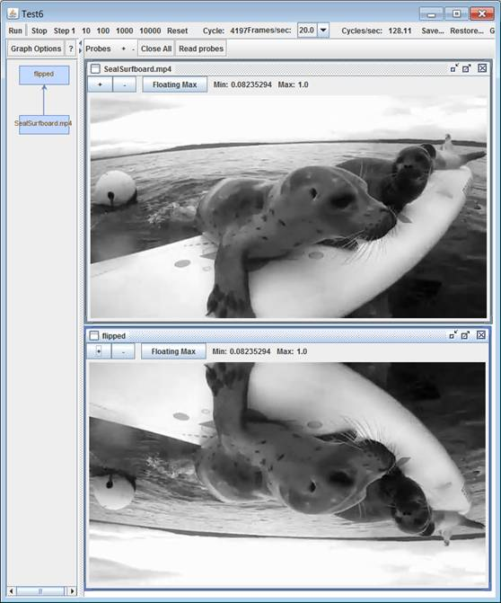

The custom operator is implemented as follows:

/** Operator to flip a 2D scalar field upside down. */

object upsideDown extends Operator {

  def compute(in: ScalarFieldReader, out: ScalarFieldWriter) {

    out.setShape(in.fieldShape)

    for (row <- 0 until in.rows; col <- 0 until in.columns) {

      val pixel = in.read(row, col)

      out.write(in.rows - row - 1, col, pixel)

    }

  }

}

Because of the potential performance bottleneck of these user-defined operators, their use is discouraged in favor of the more powerful GPUOperator facility described next.

## 4.16 GPUOperators

GPUOperators deliver the power of GPU’s to user-defined operations. This facility is recommended for the more advanced modeler who has some familiarity with GPU hardware architecture and performance issues. Keep in mind that when a user’s needs can be met through a composition of the existing Cog operators, it’s best to let the Cog compiler create optimized kernels for the GPU based on that description.

Because of the intricacies of writing GPUOperators, their use is described in a separate document *User-defined GPU Operators on Cog X*.

## 4.17 Further operator documentation

The operators described thus far are some of the most important ones available within the Cog programming framework. However, a fair number of additional Cog operators exist that are perhaps used less often or only within certain modeling domains. Please see appendix A for documentation of all Cog operators.

# 5. Programming Cog Applications

Although we’ve discussed tensor fields and the operators that can combine them into new tensor fields, we’ve not yet shown how use them to construct an application. This chapter explores how to program Cog, starting with simple feed-forward computation then moving to computation with feedback for implementing applications that need to adapt and learn.

## 5.1 Feed-forward computation

The following figure shows the high level model for feed-forward computation. External data is brought in to the computation through sensors, transformed by field computations, then written back out through actuators.

sensor

actuator

actuator

Field computation

*inputs*

*outputs*

sensor

sensor

Each sensor or actuator contains two buffers, called the master and slave, and behaves much like a master-slave flip-flop. Computation uses a 2-phase clocking model, where each computational step consists of a phase 1 clock followed by a phase 2 clock.

master

slave

phase 2 clock

phase 1 clock

sensor

or

actuator

Thus a more detailed view of the computation looks like this:

phase 2 clock

phase 1 clock

master

slave

master

slave

master

slave

master

slave

master

slave

Field computation

actuators

sensors

*inputs*

*outputs*

When the ComputeGraph is reset, each sensor fills its master buffer with initial data. It then executes a single computational step to “prime” the computational pipeline.

A computational step involves a two phase protocol:

In phase 1 of a clock cycle, each slave buffer logically fills itself with a copy of the field data from its associated master buffer. This frees up all master buffers and immediately allows the following to proceed in parallel:

1. Sensors fill their master buffers with new data from their external source (such as a video stream).
2. The field data in the input slaves flows up through the field computation to the inputs of the actuator master buffers.
3. Actuators write their slave buffers out to an external sink (such as a video display).

In phase 2 of a clock cycle, each master buffer latches its input data. For a sensor, the master input data is supplied by an external source such as a video camera, microphone, or file; data. For an actuator, the master input data is supplied by the field computation. The actuator slave data present initially upon reset can be supplied by an optional argument to the Actuator’s constructor, but is by default 0.

This 2-phase clocking complicates the computational model a bit, but this is compensated by greater parallelism: while field computation proceeds, the sensors can be concurrently loading in input data to their master buffers, and actuators can be concurrently reading out data from their slave buffers. Note that this implies a delay of one computational step or cycle between the input to a sensor and the output of an actuator.

Field computation is conceptually done in a data-flow style and involves no clocking. In the following figure, the + operator adds inputs from Sensor A and Sensor B as soon as they become available at beginning of phase 1. The convolve operator depends on the result of the + operator, so it waits for that to complete, then performs the convolution of that sum with the data from Sensor C.

Actuator

+

convolve

Sensor A

Sensor B

Sensor C

Field

computation

Here’s a Cog program that implements the computation shown in the previous figure:

new ComputeGraph {

val sensorA = Sensor(...)

val sensorB = Sensor(...)

val sensorC = Sensor(...)

val result = (sensorA + sensorB) convolve sensorC

new Actuator(result, ...)

}

## 5.2 Feedback for adaptation

Field computation is necessarily feed-forward; it is not possible to express feedback loops there (the Cog compiler will complain if you try to do something like x = x + 1). However learning and adaption requires feedback. This is accomplished with the <== operator which can be used to change the value of a “constant” field input at the end of each cycle. A “constant” field which its value changed each cycle by the <== operator is called a recurrence.

Constant fields and recurrences alter the feed-forward compute model only slightly:

constant

actuator

actuator

Field computation

*inputs*

*outputs*

sensor

recurrence

<==

Constant fields and recurrences are treated as inputs to the field computation just like sensors. Recurrences are initially declared as constants and then “mutated” into recurrences using the <== operator:

val x = ScalarField(...) // x is a constant field.

val y = ScalarField(...) // y is a constant field.

x <== x + 1 // x has been changed into a recurrence,

// y is still a constant.

val z = x + 1 // z in NOT a recurrence, its value is calculated

// with the current value of x.

The change of x’s value, though, is not immediate but delayed until the following cycle. This is because recurrences have the same master/slave buffer structure as sensors and actuators:

master

slave

recurrence

<==

During field computation, the slave buffer provides the field data used by the computation (this slave field data is the result of the computation during the previous step). But the next state for the recurrence value (x + 1 in the above example) is driven to the master buffer, and is thus not visible until the next compute cycle. This eliminates possible race conditions that could otherwise occur and also prevents cyclic computations that could (at least in principle) oscillate forever.

## 5.3 Reset and step

Resetting a ComputeGraph initializes all fields in the computation in the following steps:

1. The slave registers of all inputs are initialized with user-defined values. Constant fields are given their declared value; sensors have attached user functions which are queried for their field value; recurrences are initialized to the value given them when they were initially declared as constants.
2. The input slave registers then flow through field computation to the inputs of the actuator master buffers.
3. Finally the master buffers latch their inputs from the field computation.

slave

master

slave

master

slave

master

slave

master

slave

Field computation

*constant*

*actuator*

*actuator*

*sensor*

*recurrence*

When reset has completed, all input slave buffers, fields in the field computation, and master buffers in actuators hold valid field data. Each step thereafter then performs phase 1 clocking (copying all masters to their slaves) followed by phase 2 clocking (filling master buffers with their inputs).

## 5.4 Programming styles in Cog: Think functional

Although there are many styles in which a Cog application could be programmed, a functional style is probably the easiest. The functional paradigm considers an entire application to be nothing more than a stateless function that transforms a set of inputs to a set of outputs during a single Cog tick. The inputs are constants, sensors and recurrences fed back from the previous tick. From a functional point of view, these cannot be distinguished. The function consists of the field computation, which is stateless and propagates completely during the single tick. The sensors and the <== operator, then, are nothing more than mechanisms for supplying the function with a new set of inputs during the next tick. Two things to keep in mind as you program are the following:

1. Make a concerted effort to not use feedback unless you need to preserve some state through a Cog tick.
2. Explicitly and conceptually divide the computation into two sequential parts: 1) a feed-forward pass of the model computation, 2) an update phase in which all feedback/recurrent variables are computed

# 6. Debugging

Debugging is an important part of any application development process. This chapter describes the CogDebugger tool in greater detail than previous chapters and provides suggestions for identifying and correcting errors in Cog programs.

The Cog Ex Machina platform includes a visual debugging tool intended to help find and correct errors in applications developed on the platform. In many cases, the contents of a field are difficult to interpret in a raw numerical form, but can be visualized in a way that provides more insight into why an application is not working (or why it *is* working).

The debugger’s graphical interface consists of three major parts. The first is a set of controls for regulating the execution of a compute graph. The second is a visualization of the compute graph’s structure. The third is a ‘probe desktop’ where visualizations of a model’s various fields can be displayed. These individual parts are more thoroughly described later in this chapter.

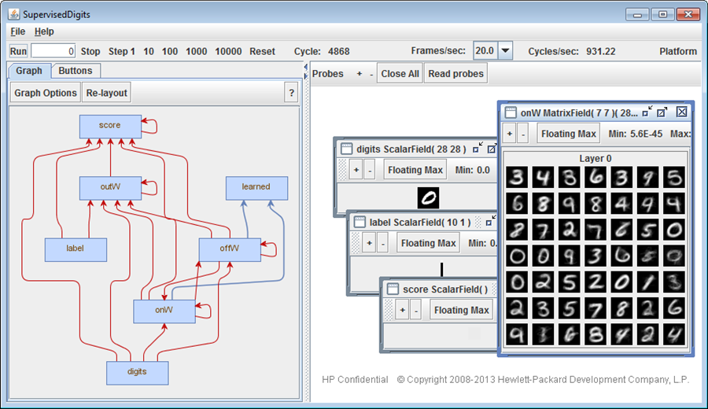

Main Toolbar (compute graph and debugger controls)

Structure Pane

Probe Desktop

## 6.1 Launching the Debugger

The CogDebugger class defines the actual graphical user interface of the debugging tool. It allows users to start, stop, step, and reset a compute graph while visualizing its structure and the contents of its fields. The simplest way to launch the GUI is to extend the CogDebuggerApp class, which wraps a ComputeGraph instance and provides a runnable main method that launches an instance of the visual debugger.

CogDebuggerApp and its related classes are members of the cogdebugger package. Note that you must define an *object* (not a class!) that extends CogDebuggerApp for the application to actually be executable, as shown below.

import libcog._

import cogdebugger._

object MultiplierDebugger extends CogDebuggerApp(new Multiplier)

class Multiplier extends ComputeGraph {

val counter = ScalarField()

val multiplied = counter * 2

counter <== counter + 1

}

The above example defines a simple application, MultiplierDebugger, that can be launched from the command line or your IDE. If you launch this app as is however, you will notice that the ‘multiplied’ field is unaccounted for in the debugger. This is due to the Cog platform compiler’s optimizer. The next section describes how to prevent the compiler from eliminating a field of interest.

## 6.2 Probing Fields

By default, the Cog compiler aggressively optimizes a compute graph to maximize its execution performance. In some cases, fields and expressions defined in a compute graph can be merged together or eliminated entirely by the optimizer, and are thus unavailable to the debugger. In the previous example, the field ‘multiplied’ is not used in any other expression and is seen as ‘dead code’ by the compiler and consequently removed. To prevent the compiler from optimizing away a field of interest, we must explicitly state in our program that we would like to ‘probe’ the field in the debugger,by calling the probe method (defined on all fields), as shown below.

import libcog._

import cogdebugger._

object MultiplierDebugger extends CogDebuggerApp(new Multiplier)

class Multiplier extends ComputeGraph {

val counter = ScalarField()

val multiplied = counter * 2

counter <== counter + 1

probe(multiplied)

}

The previous example has been modified to ensure that the ‘multiplied’ field appears in the debugger. Alternatively, ComputeGraph also defines a probeAll method that essentially disables the optimizer. This causes the computation to execute more slowly, but every field will be available for inspection in the debugger. Note that sensors and actuators are never eliminated by the compiler and do not need to be explicitly probed. Lastly, also be aware that a field’s probe method accepts an optional user-defined String to use as the field’s name in the debugger, though the default name, derived from the val or var to which the field is assigned, usually suffices.

## 6.3 Controlling the Computation

The main toolbar across the top of the debugger window serves as home to all the controls for starting, stopping, and resetting the computation, as well as a control for the maximum rate at which field visualizations update. It also displays the current cycle of a running computation and the rate at which it is advancing. An example of the toolbar (taken from a running app) is shown below.



In order of their appearance on the toolbar (left to right), the provided controls and displays are:

1. **Run** – Steps the compute graph continuously and as fast as possible. The running computation can be interrupted by pressing **Stop**, or be made to end after achieving a certain cycle count by setting the **Cycle Count Box** to a number other than zero.
2. **Step Count Box** – Controls how many steps will be executed by pressing the **Run** button. If set to 0, the model will execute until **Stop** is pressed. If a number is entered, pressing **Run** will only execute that many steps before stopping.
3. **Stop** – Stops a running computation, regardless of how it was started or if it had queued steps remaining.
4. **Stepping controls** – Steps the computation a fixed number of times (in powers of ten from 0 to 4). These buttons are provided for convenience, as the same can be achieved through use of the **Step Count Box** and **Run** button. These buttons can be pressed again while the computation is executing to enqueue additional steps (e.g. double-clicking ‘1000’ will cause the model to execute for two-thousand cycles before pausing). These buttons have no effect if the computation is executing as a result of pressing the **Run** button.
5. **Reset** – Resets the current computation to its initial state (at step zero). Any currently executing computation is first stopped.
6. **Cycle Counter** – Displays the current step of the computation.
7. **Frames/sec Dropdown** – Controls the maximum rate at which field visualizations will update and redraw themselves.
8. **Cycles/sec Counter** – Displays the rate at which the computation is executing (in Hertz)
9. **Platform** – Prints information to the console about the OpenCL platform detected in the system and any installed GPUs.

## 6.4 Viewing Compute Graph Structure

The left panel of the debugger window is dedicated to visualizations of a ComputeGraph’s structure. Using the tabs at the top of the panel, you can choose among the different visualizations, which may show or more less detail or simply present the graph structure in different ways. These visualizations also provide the means for launching the visualizations of individual fields in a compute graph, which are covered in section 7.1.4.

The default visualization for a compute graph’s structure is the Graph View. The compute graph is displayed as directed node graph, with each field in the computation presented as a vertex (labeled according to the field name), and each edge indicating data flows between fields. Blue edges represent the feed-forward data flow of the computation – that is, clock phase 1 (see section 5.1). Red edges are feedback edges; data is passed along them in clock phase 2 (section 5.2). Note that a ‘step’ in the debugger consists of both clock phases.

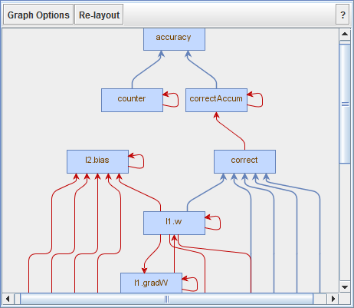

Any vertex in the graph can be clicked to launch the default visualization for the associated field. The visualization appears on the Probe Desktop (see section 7.1.4). If multiple visualizations exist for a particular field, right-clicking the field will pop-up a context menu with the alternatives. Note that clicking (left or right) a field for which a visualization is already open on the desktop will bring that visualization to the foreground, rather than open a new visualization.

Depending on the complexity of your application, the basic graph can get very large and cumbersome. To cut down on the number of displayed vertices and edges, the graph view can optionally group fields into *modules*. A module is just some object with references, direct or indirect, to fields and other modules. Those fields and modules directly accessible from a given module are said to be children of or contained in that module. Thus, a module hierarchy is implicit in the definition of any ComputeGraph, with the class extending ComputeGraph serving as the root or top-level module. Consider the following example Cog program:

import libcog._

import cogdebugger._

object ModuleExampleDebugger extends CogDebuggerApp(new ModuleExample)

class ModuleExample extends ComputeGraph {

val foo = new Foo

val bar = new Bar

val scalarField = foo.scalarField + bar.scalarField

probe(scalarField)

}

class Foo {

val bar = new Bar

val scalarField = bar.scalarField * 2

probe(scalarField)

}

class Bar {

val scalarField = ScalarField()

scalarField <== scalarField + 1

probe(scalarField)

}

Four scalar fields exist in this compute graph implementation. One in the ModuleExample instance, one in an instance of Foo, and one in each of two instances of Bar. From the perspective of the ModuleExample instance, each of these fields can be accessed by a different chain of references, e.g. ‘scalarField’ refers to a different field than does ‘foo.bar.scalarField’. Only the first scalarField is directly accessible from the ModuleExample instance, the others are only accessible through a Foo and Bar object. Thus, the ModuleExample instance defines a single module containing one field and two sub-modules.

To see the modules into which a compute graph can be divided, click the **Graph Options** button in the graph view’s toolbar, and then select **Show Modules**.

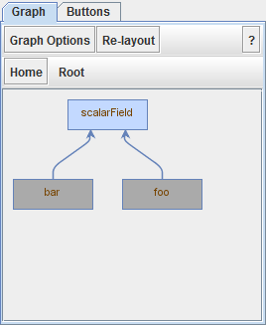 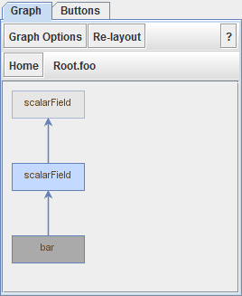

In this mode, the view is focused on a single module at a time, indicated on the secondary toolbar (that only displays in this mode). The child fields of the currently focused module are displayed as blue vertices and child modules as dark grey. Edges that go to or originate from fields outside the focused module are not left dangling, but connect to ghosted, light grey vertices labeled with the full path of the field. Clicking on a field vertex launches a visualization as before, but clicking a module selects that one as the new focus and redraws the graph from the perspective of that module. Clicking one of the ghosted vertices corresponding to an outside field focuses that field’s parent module. In this way, you can navigate the module hierarchy to find any fields of interest for probing. You can navigate back to the root module at any time by clicking the **Home** button on the secondary toolbar.

Lastly, if you’re not interested in the structure of the compute graph but simply want to launch a visualization for a particular field, the Buttons View dispenses with edges entirely. Simply select the **Buttons** tab to be presented with a collection of buttons, one per field in the model, labeled by the corresponding field name and sorted in alphabetic order. As with field vertices in the graph view, left-clicking a button opens the default visualization for the corresponding field, while right-clicking presents all available options.

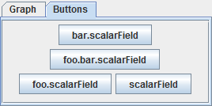

## 6.5 Visualizing Field Contents

The last pane of the debugger is the Probe Desktop. This is where the visualizations for fields will appear when a field vertex or button is clicked in the structure pane. Each visualization opens in its own window that can be moved, resized, minimized, and maximized, and that has its own toolbar to adjust and control the visualization. While most visualizations can be zoomed by using the **+** and **–** buttons on the toolbar, they do not automatically adjust zoom level as the size of their window changes.

In order to update the visualizations, any ongoing computation must be briefly paused to ensure data consistency and that all the data that produced a visual came from the same cycle of the computation. As a result, opening many visualizations simultaneously can impact the performance of a running app. The maximum rate at which visualizations will update and rerender can be controlled by the **Frames/sec** dropdown on the main toolbar. Note that some visualizations are computationally expensive to render and may not achieve this target update rate. You can request that all visualizations update and rerender at any time by clicking the **Read Probes** button on the desktop’s toolbar.

## 6.6 Standard Field Visualizations

The aim of this section is to familiarize you with the standard visualizations that are part of the Cog Debugger tool. Depending on the type and shape of a field, different visualizations are available. For example, a field consisting of two-dimensional vectors can be displayed as a grid of grid of arrows with varying orientations and lengths, but the same visualization doesn’t make sense for a field of scalar values.

### 6.6.1 Scalar Fields

The default visualization for scalar fields is simply called **Scalars**. It produces a grayscale image where each pixel represents a single value in the field (in 3D fields, each layer or plane is sliced out into a separate image). With 0 representing pure black, and 1 representing pure white, the color mapping for a value *x* in the field is:

color = (*x* - min) / (max - min)

min

max

The values *min* and *max* are determined by the state of the **Floating Max** toggle button on the visualization’s toolbar. If the button is toggled on, they are the minimum and maximum values in the field at the current cycle. If the button is toggled off, they are the minimum and maximum values recorded in the field since the last reset.

An alternate viewer, **Grayscale Image**, is available only for two-dimensional scalar fields. It does no scaling to values within the field - values are simply clamped to the range [0, 1]. This has the benefit of faster rendering than the default view, but will produce artifacts if the values within your field aren’t already inside that range.

### 6.6.2 Vector Fields

The default visualization for vector fields extracts two components from each vector to produce a 2-dimensional geometric vector, drawn as a single directed line with a length proportional to the magnitude of the original vector. If the vectors are abstract vectors (their dimensionality does not match the dimensionality of the field or space in which they are contained), which components are extracted can be selected by clicking the **Options** button on the visualization’s toolbar. The rendered vectors can also be flipped across the x or y axes.

An alternate visualization, **Color Flow**, is available only for two-dimensional vectors. Each vector is rendered as a single colored pixel. The hue of a pixel encodes the direction of the corresponding vector, and saturation the magnitude. The **Clamp To** value in the toolbar determines the magnitude at which a pixel will be fully saturated.

A third visualization, **Components**, collects the like components from each vector and displays each set of components as a scalar field. For example, a field containing two-dimensional geometric vectors would be visualized as two scalar fields – one containing all the *x* values and the other all the *y* values.

### 6.6.3 Matrix Fields

The default viewer for matrix fields, named **Matrices**, produces a grayscale image for each matrix, in the same manner as the default scalar field viewer does for a two-dimensional scalar field. As with the scalar field visualization, the **Floating Max** button determines whether the color mapping uses the current cycle min and max values or the min and max since last reset.

# Appendix A: Field Operator and Function API

The documentation of Cog operators and functions in the following pages was generated by Scaladoc2, a tool that extracts and formats their description directly from the source code. The descriptions that follow are organized in three parts:

1. A CogOperatorAPI that includes methods on the Field class, such as the arithmetic operators than can appear in an infix notation like field1 + field2.
2. A CogFunctionAPI that includes keyword-based functions that operate on Fields, like convolve(image, filter).
3. Implicit conversions that can occur within Field expressions.